Getting Your Snap! Account
Snap! is different than many other programming languages— you run it in a web browser like Firefox or Chrome. The URL that you can use to always get to Snap! is
http://snap.berkeley.edu/run
You may want to create a “bookmark” in your browser for this; we’ll be using it A LOT!
- When you click on the link, and you should see a screen like this: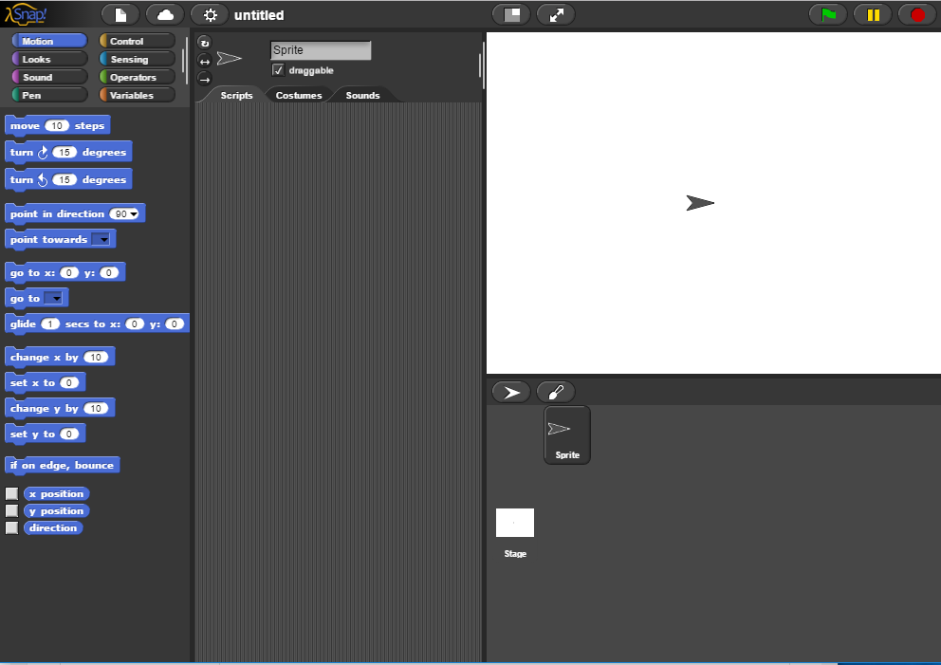
If you DO NOT see this screen, contact your RM for support.
- In order to save your programs, you need to create an account. In the Snap! window, find the cloud-shaped button in the top toolbar on the upper left corner of the window:
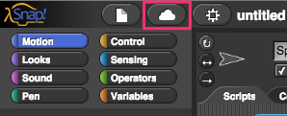
Click it, select the "sign up" option in the menu, and you should see this:
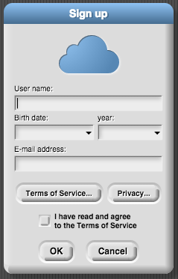
Fill it in as follows:
- User name: Choose a user name that will identify you on the web site, such as Jens or bh. Don’t pick something you’d be embarrassed to have other users see! If the name you want is already taken, you’ll have to choose another one.
- Birthdate and year: We ask for your month and year of birth; we use this information only to decide whether to ask for your own email address or your parent’s email address. We do not store your birthdate information on our server; it is used on your own computer only during this initial signup. We do not ask for your exact birthdate, even for this one-time purpose, because that’s an important piece of personally identifiable information.
- Terms of Service: Click on this and read them - they’re not long, and easy to understand. A quick summary:
  - Don’t interfere with anyone else’s use of the web site, and don’t put copyrighted media or personally identifiable information in projects that you share with other users.
  - We’re not responsible if something goes wrong. (Not that we expect anything to go wrong; since Snap! runs in Javascript in your browser, it is strongly isolated from the rest of your computer. But the lawyers make us say this.)
THEN check the box that says “I have read and agree to the Terms of Service”
DO NOT PRESS OK YET!!!!
- IMPORTANT: Take a screen shot of your Sign up window and save it!
- When you click OK, we will send an email to the email address you gave, with an initial password for your account. We keep your email address on file so that, if you forget your password, we can send you a password reset link. We will also email you if your account is suspended for violation of the Terms of Service. We do not use your address for any other purpose. You will never receive marketing emails of any kind through this site, neither from us nor from third parties.
- Check your email for your temporary password. If you do NOT receive it within an hour, check the “spam” or “junk” mail folders on your mail system. If you still don’t see it, submit the screen shot of your Sign up window with a comment that explains how your check for spam and junk mail.
- Click on the cloud button again, and this time sign in:
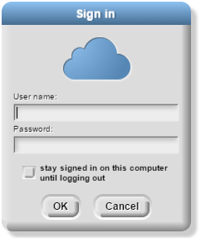
Use the user name you entered above and the password that we mailed to you. If you check the “Stay signed in” box, then you will be logged in automatically the next time you run Snap! from the same browser on the same computer. Check the box if you’re using your own computer and you don’t share it with siblings. Don’t check the box if you’re using a public computer at the library, at school, etc.
- To make sure everything is working, click on the Document button on the top left, and select Save as…
Name your project “Lab 0.1” and click Save
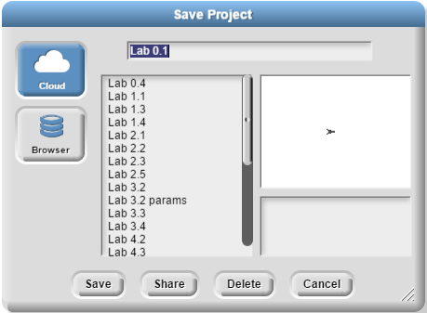
- Finally, click the Document button again, click on the project you just saved, and this time click Share. It will ask to you confirm that you want to publish it, so click Yes.
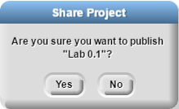
- Now you can just click Cancel to return to the Snap! window. Notice that the URL address in your browser has changed to something like:
snap.berkeley.edu/snapsource/snap.html#present:Username=yourname&ProjectName=Lab%200.1

