The Misconception Game:
Pretend you are working with a student struggling with an assignment and attempting to help. You only have a few minutes to unblock the student. Don’t tell the student the answer and don’t worry about getting completely resolved; focus on giving the student a clear next step to try. How would you approach helping this student get to the solution to the problem below. (Choose two problems corresponds with your curriculum.)
 | AP CSP Instructions | Student Code | Student Code Output
AP CS Principles | Draw an equilateral triangle with sides that are 75 pixels long. Remember that each interior angle of an equilateral triangle is 60º  from Code.org 3.7; similar to MobileCSP 5.2 or BJC 1.3 (see below) | 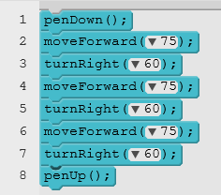 | 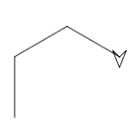
 | TEALS Intro Instructions | Student Code | Student Code Output
TEALS Intro | Draw an equilateral triangle when the number 1 is pressed on the keyboard. Remember that each interior angle of an equilateral triangle is 60°  TEALS Intro Lab 1.3 (similar to CSP BJC 1.3) | 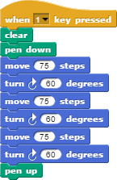

 | AP CS A Instructions | Student Code | Student Code Output
TEALS AP CS A | Write a complete Java program to produce the following output.  *****  *****  *****  *****  Lesson 2.06,  Practice-It 2.4 | public class Square {  public static void main(String[] args) {  for (int i = 1; i <= 4; i++); {  for (int j = 1; j <= 5; j++) {  System.out.print("*");  }  System.out.println();  }  }  } | *****

Student Thinking:
AP CSP & Intro: I know an equilateral triangle has angles of 60º, and that’s how much I’m turning right but my turtle is clearly not drawing a triangle.
AP CS A: It prints out five stars, so the j loop is working but I don’t know why it stops after only one line
Student Mistake:
AP CSP & Intro: Student is using the interior angle (60º) to turn the turtle but should be using the exterior angle (180º - 60º = 120º).
AP CS A: Student has a misplaced semicolon on the first for loop line

The Misconception Game: Round 2
 | Instructions |  | Student Code |  | Student Code Output
AP CS Principles | 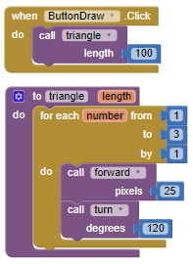  Design an algorithm for drawing an equilateral triangle -- i.e., a triangle with equal sides and equal angles. Because this is another example of a repetition, you can use the for-each block in your algorithm. Because you might want to use your triangle algorithm again, define it into a procedure with a parameter.  MobileCSP 5.2
TEALS Intro (Lab 3.2) | Take the script you wrote in the last lesson that draws a square. Modify your script to ask the user input for a number of sides and a side length.  Part a) Adjust the script so that the size of the square is the size given by the user.  Part b) Adjust the script so that instead of a square, it draws a polygon with the numbers of sides given by the user. |  |  | 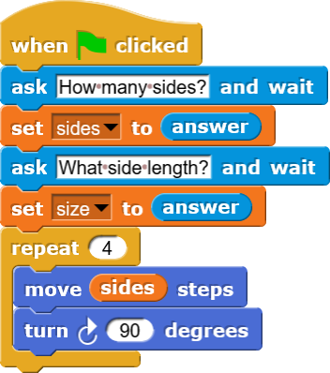
TEALS AP CS A | Write a complete Java program to produce the following output.  /\ /\  / \ / \  +------+ +------+  | | | |  +------+ +------+  |United| |United|  |States| |States|  +------+ +------+  | | | |  +------+ +------+  /\ /\  / \ / \ | public class TwoRockets {  public static void main(String[] args) {  printCap();printCap();  printBox();printBox();  printUS();printUS();  printBox();printBox();  printCap();printCap();  }  public static void printCap() {  System.out.println(" /\\ ");  System.out.println(" / \\ ");  }  public static void printBox() {  System.out.println("+------+");  System.out.println("| |");  System.out.println("+------+");  }  public static void printUS() {  System.out.println("|United|");  System.out.println("|States|");  }  } |  |  |  | Some output  /\  / \  /\  / \  +------+  | |  +------+  +------+  | |  +------+  |United|  |States|  |United|  |States|  +------+  | |  +------+  +------+  | |  +------+  /\  / \  /\  / \

Student Thinking:
AP CSP: Whenever I call triangle, it doesn’t matter if I give it 100 or 20, it’s always the same size.
Intro: I made this polygon block so I could change the size and the number of sides, but no matter what numbers I put in, it’s not working right. Here it should be a size 50 square, but it’s not.
AP CS A: I printed the rocket twice, but it didn't show up like it should.
Student Mistake:
AP CSP: Student put in a variable, but is not using it in the function.
Intro: Student is moving “sides” instead of “size” also should be using “repeat (sides)” not repeat(4). Moving forward, they also need to think about how they’ll make this work correctly for any number greater than 2.
AP CS A: Students put functions side by side thinking that's how the picture would show up.

